**Galaxy S5 (portrait)**

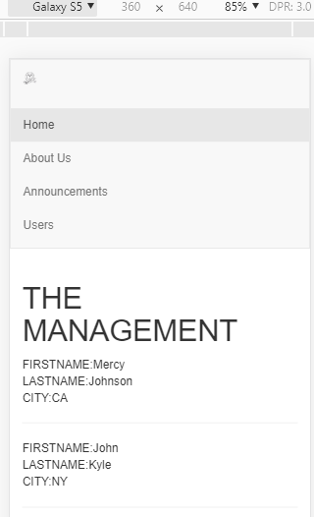

**Galaxy S5 (landscape)**

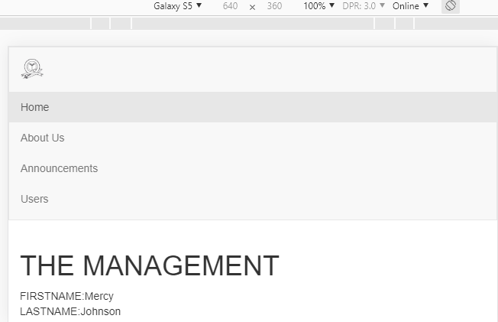

Users viewing the site on galaxy s5 have no styling issues. The menu items are clearly displayed. The only style issue appears on the logo. It is more aligned on the left with less display.

**iPhone 6(portrait)**

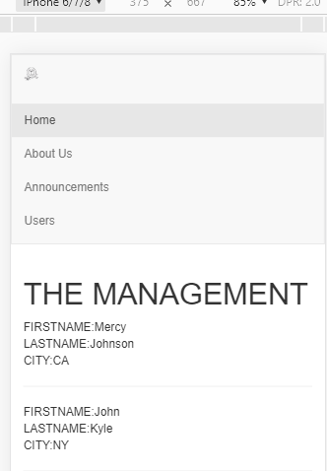

**iPhone 6(landscape)**

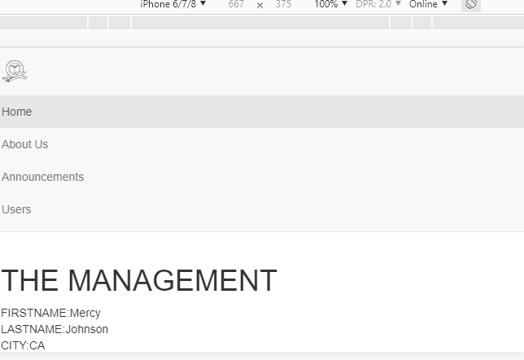

Users on this devices just like other users on the small devices have an issue with the logo. It appears not aligned with the rest of the contents on the page.

**iPad Pro(portrait)**

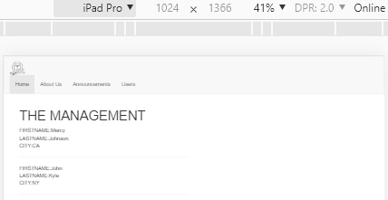

**iPad Pro(landscape)**

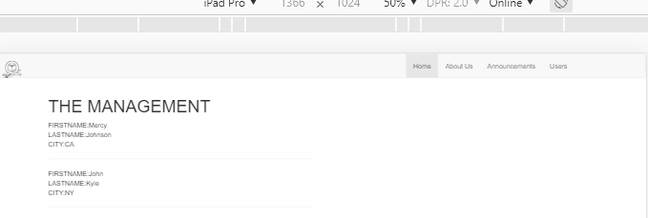

The only styling issues that the users on this device is also on the logo. The logo pixels and alignment in relationship to the other website content appears squeezed.